AZURE INFRASTRUCTURE SETUP

Creating Resource Group
- For everything we do in Azure portal, we need a Resource Group.
- Resource Group is a container that host all the related resources like VMs, Containers, NSG- Network Security Groups.
- Once project get’s over, we need to delete all resources but removing individual resource is a tidy process, so we can use Resource Group.
- If we delete the Resource Group, all the resources it contains will be deleted one go.
- To create Resource Group in Azure portal, type Resource Group you will find, give the subscription, Name, Region and then tags to create.
- There’s no rule that resources should be present in the same region as Resource Group region. They can be at different regions.
- 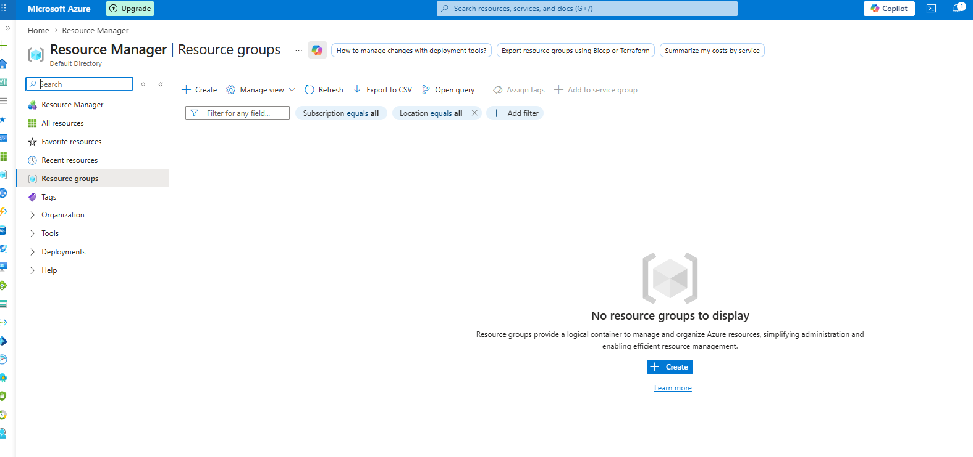
- Now we are inside Resource Group, click on create to create a new Resource Group.
- 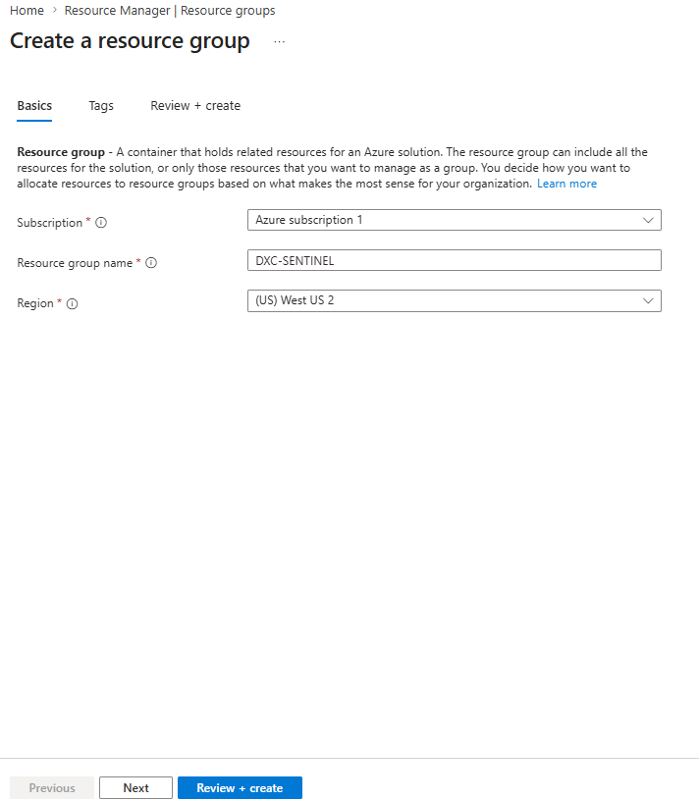
- Provide the region and name and then click next.
- Review and create.
- Now we have a resource group to store all the resources we create in Azure portal.
- We need a network to communicate and protect our resources we create like VMs.
- In Azure we have Virtual Network and we break down them in to segments called subnets to host applications, DB, we can apply ACL to control traffic that goes in and comes out of the VLAN.
- We can use peering to communicate with different vnets.
- To create Vnets, type Vnets in azure portal.
- 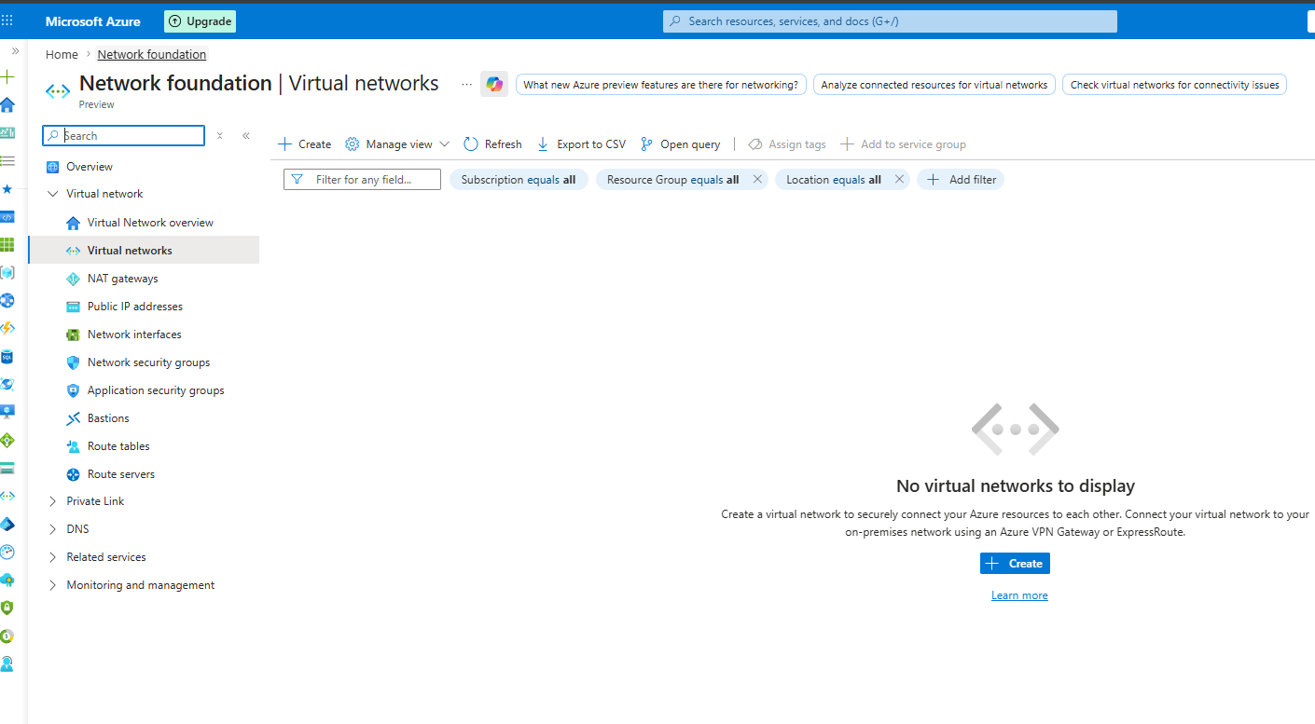
- Now click on create to create a Virtual Network.
- 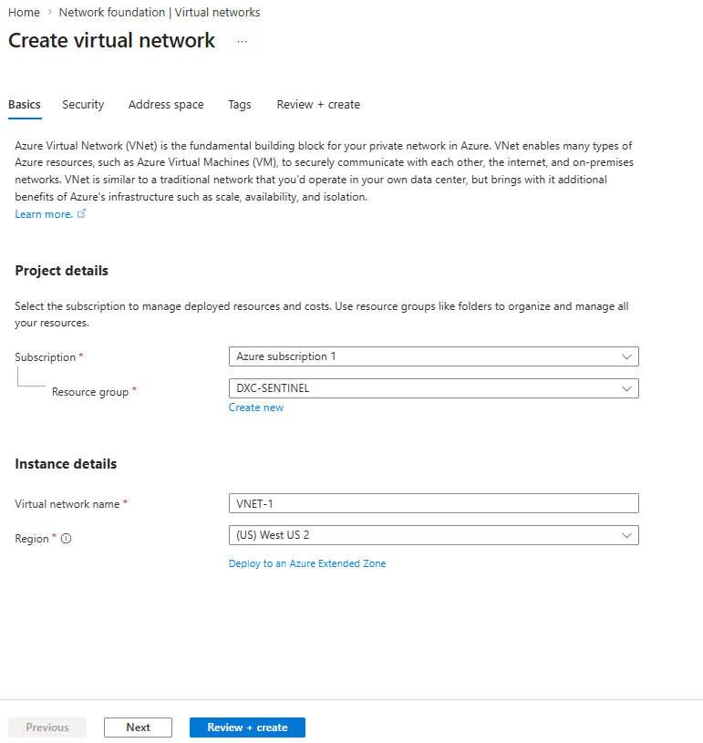
- Now provide the Subscription, Resource Group, Name and then region under Basics tab.
- Under security, don’t select anything as this is for lab infrastructure and we may end up loosing our credits.
- 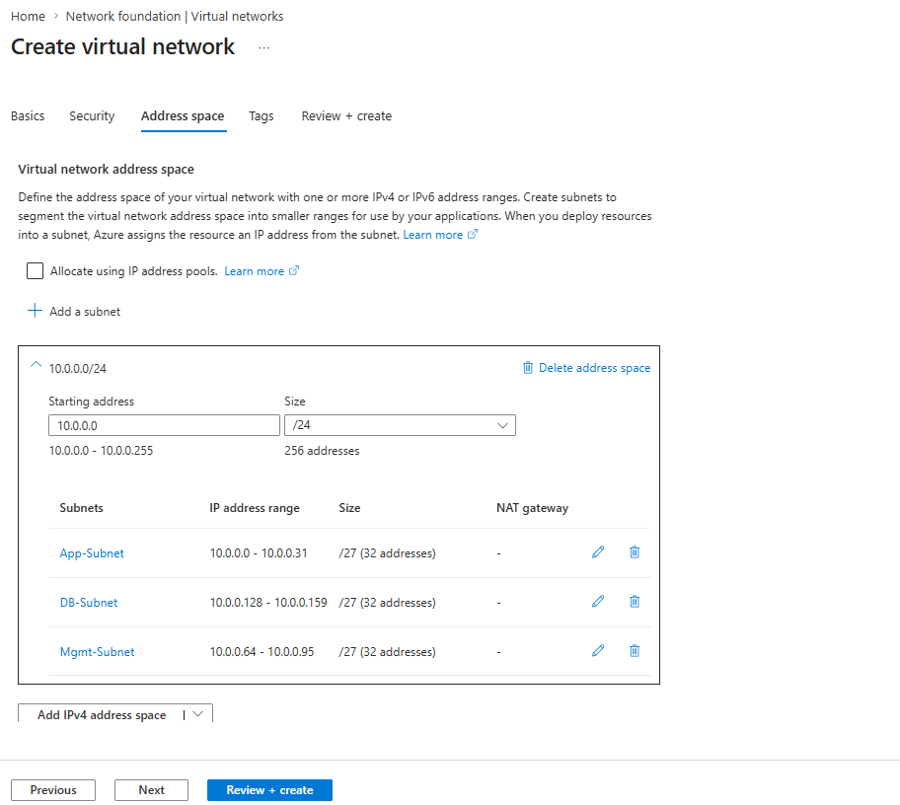
- Create subnets and provide tags.
- Then click review and create.
- Now we create Virtual Machines as part of our infrastructure development.
- We need Vms to store our applications to do our day to day jobs.
- To create VMs type Virtual Machine in Azure portal and then click create.
- 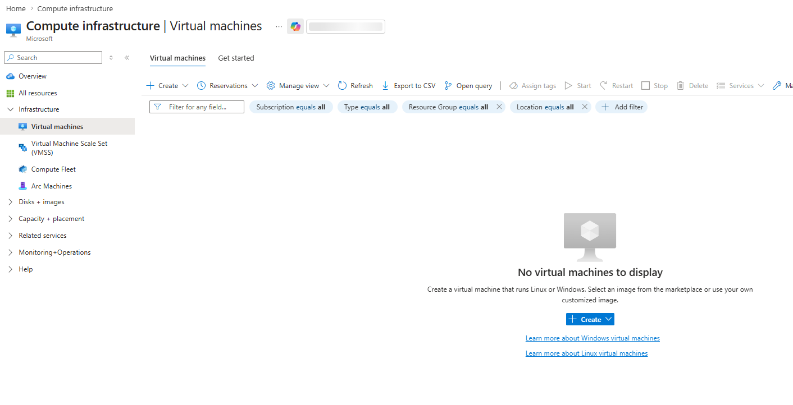
- For our trial we will be provided with 4cpu cores, so choose according to it.
- 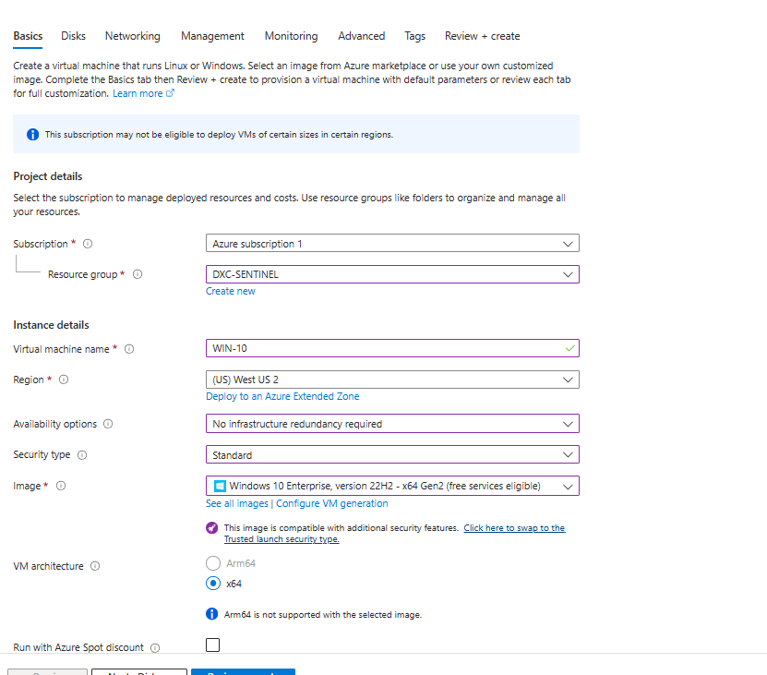
- 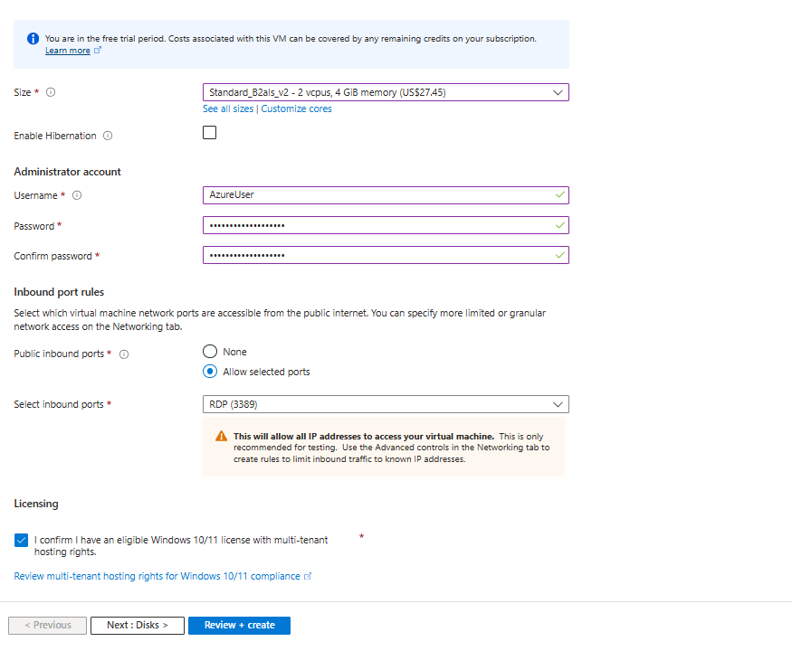
- Click next.
- 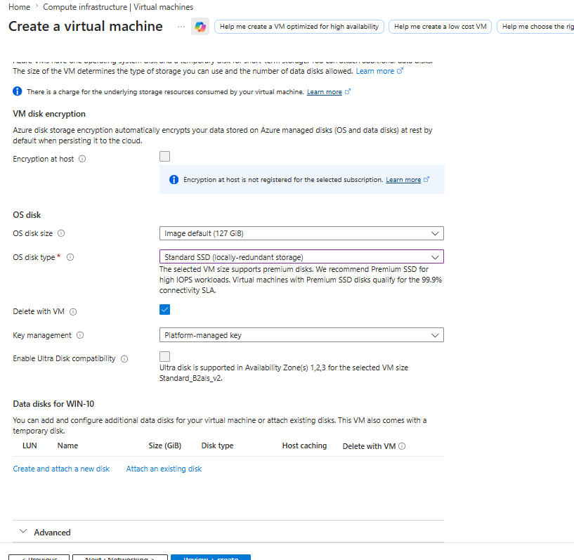
- 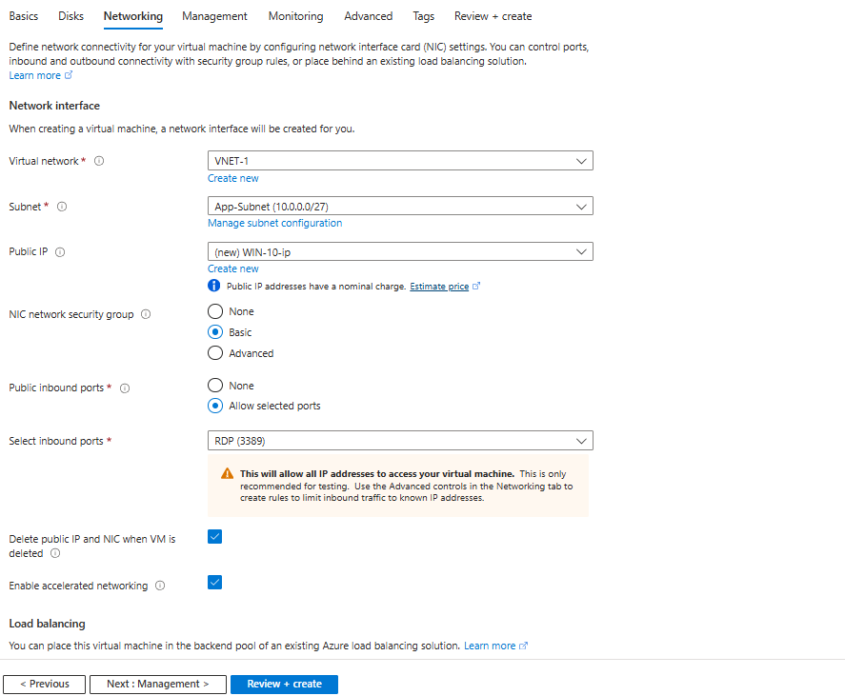
- Select the Delete Public Ip and NIC when VM is deleted.
- Then Review and create.

- Now we create Azure Storage Account to store files.
- In search type Storage Account -> select and create, provide Resource Group, storage account name, region, performance -> standard, redundancy -> LRS 3 copies of data in same Data centre.
- 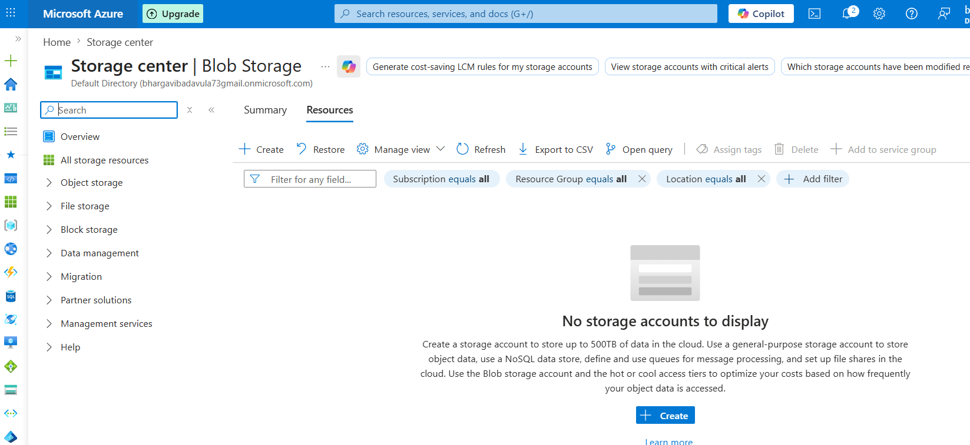
- 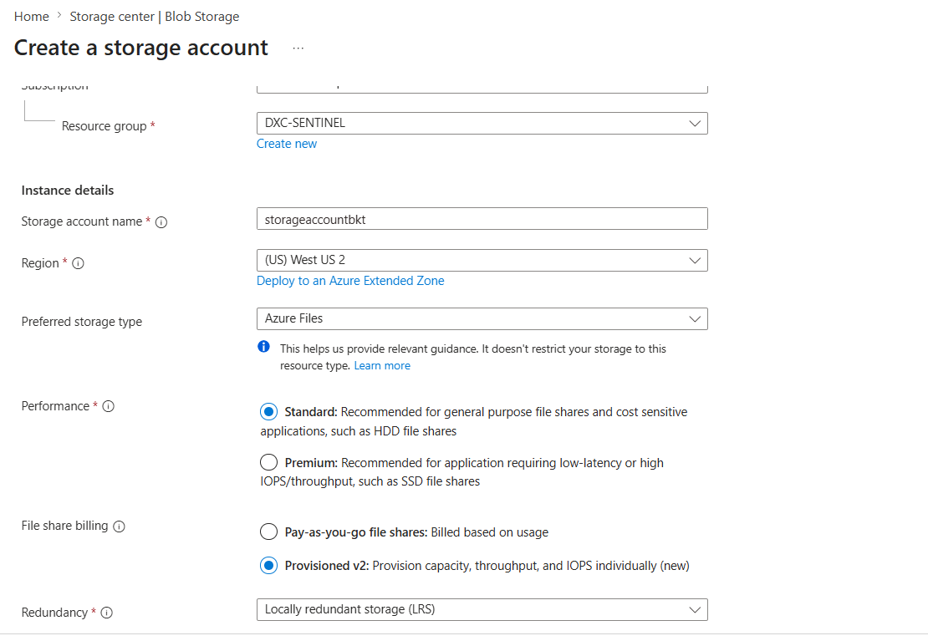
- Let other tabs have default selections and proceed to Review and create.
- After storage account got created, upload some data into it.

Monitoring Service in Azure
- We use Azure Monitor to monitor Azure Services and resources in Azure.
- Azure Monitor and Log Analytics Workspace very critical for Sentinel.
- Azure Monitor is for Monitoring and LAW is for logging.
- Log Analytics: It’s a log storage repository. It also provides capabilities to query logs for analysis purpose.
- If we want to collect logs from other sources like AWS, GCP, on premise we install Azure Monitor Agent on them.
- Agent is used for only compute resources.
- For routers, switches, we will be using CEF framework, CommonEventFormat and syslog.

